Based on the shake detection code develop the app that stores at least three songs and upon shaking the app play the next song on the list.

Mainactivity.java : A 'TextView' is added to the shaking detecting music player app's revised 'MainActivity' class to display the name of the currently playing song. The 'prepareMediaPlayer' method now updates this 'TextView' with the song's name using the 'getSongName' method, in addition to setting up song playback. This approach connects the song's resource ID to its title, improving user experience by visually identifying which song is playing, which is especially important when songs change due to device shaking.

NOTE : I also added the name to which song is playing by using getsongname

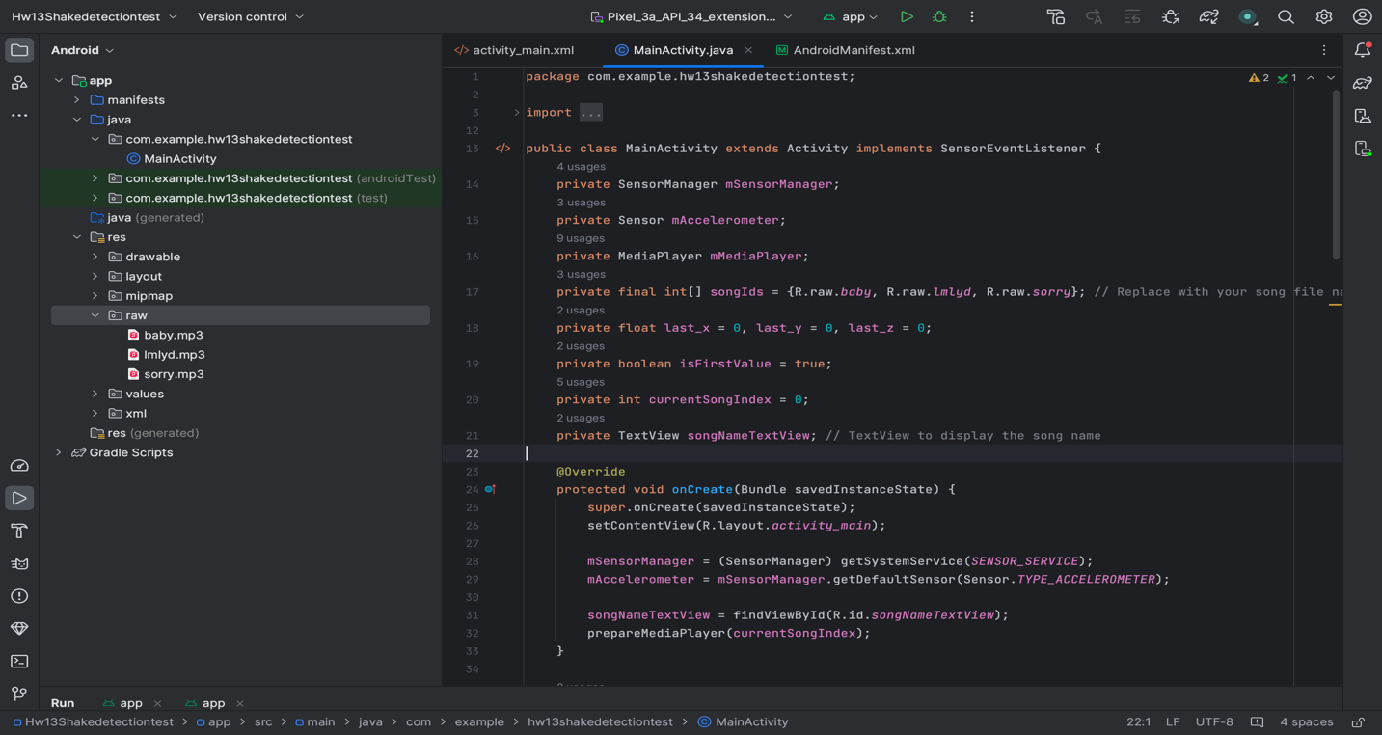

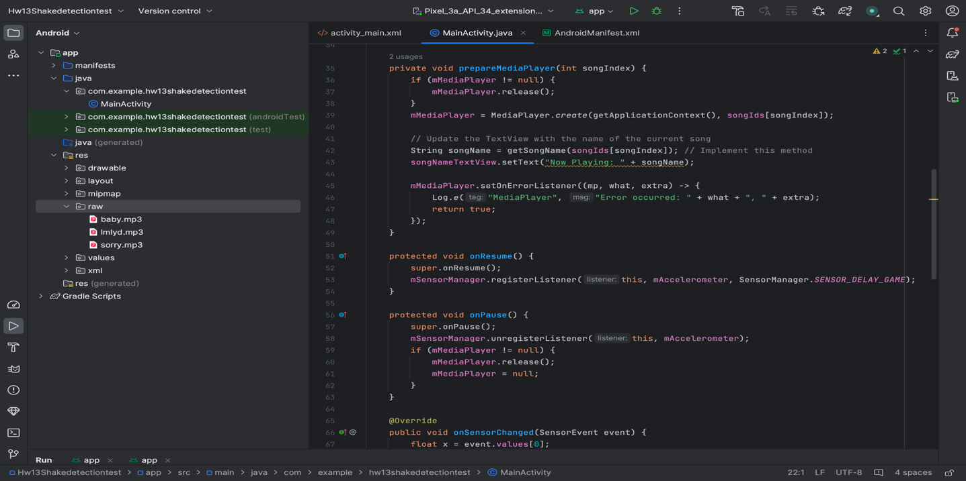

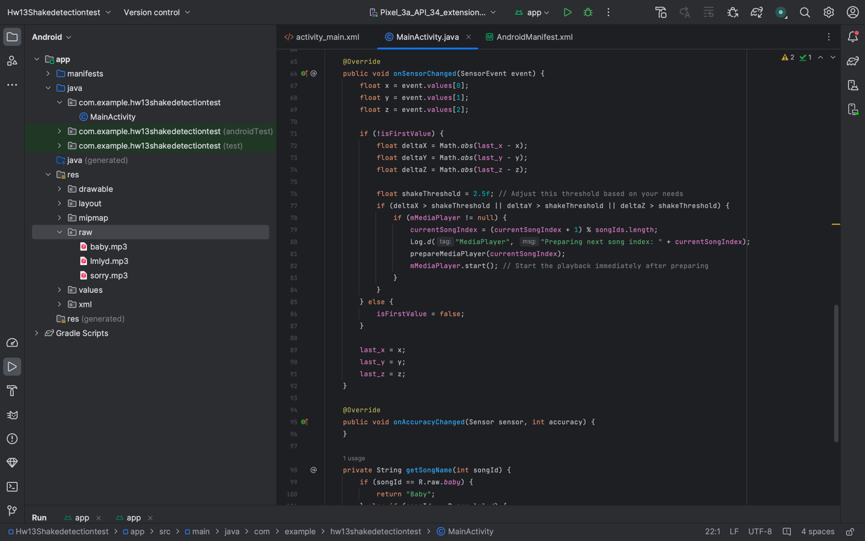

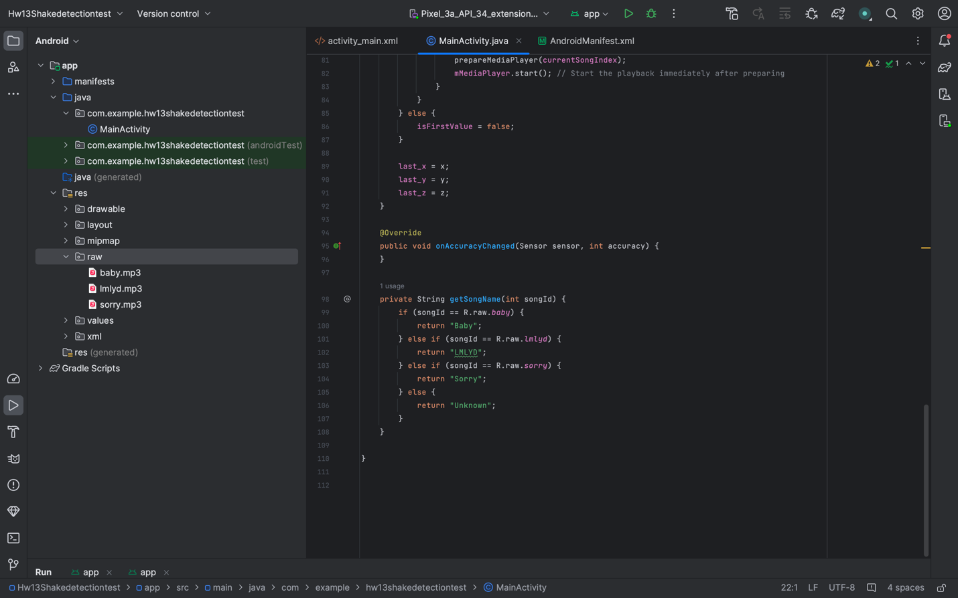

Activity_main.xml : This Android app's XML layout has a 'RelativeLayout' with two 'TextView' widgets. The first 'TextView' 'instructionsTextView' is in the center of the parent layout and displays instructions to shake the device to play a song. The second 'TextView' 'songNameTextView', by default positioned in the upper left corner, is meant to display the name of the currently playing song, with its initial text set to "Song Name." The layout is intended to be simple, with a focus on delivering user instructions and displaying the title of the current music.

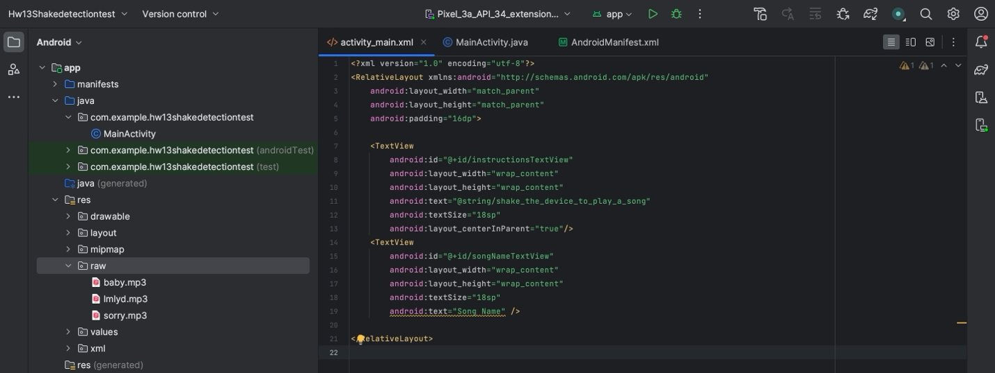

Android manifest.xml : The '<uses-feature>' element in the Android manifest file says that the app requires the device's accelerometer sensor, which is required for the shaking detection capability. The app assures that it will only be available on smartphones that have an accelerometer by setting 'android:requiredFeature="true"'. The '<uses-permission>' tag demands that the app be granted permission to access the Internet, which may be required for functions like as streaming music or accessing online resources.

Below are the screenshots of the app after each shake the next song is playing I did this on my android phone but we can also do this in emulator using the visual sensors and select the option move and drag the slider so the device will recogsed as the shake.



SS of 1st song. SS of 2nd song


SS of 3rd song

